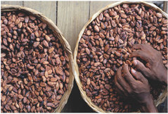
http://www.tigweb.org/youth-media/panorama/article.html?ContentID=14253
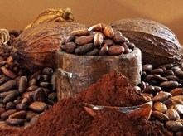
https://laundelles.wordpress.com/2012/01/
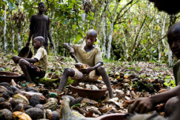
http://balitaupdates.blogspot.com/2012/01/who-loves-chocolate.html
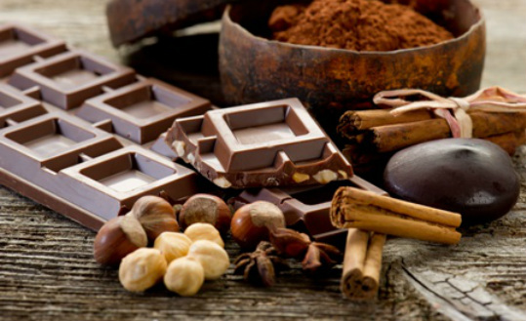
http://www.tigweb.org/youth-media/panorama/article.html?ContentID=14253

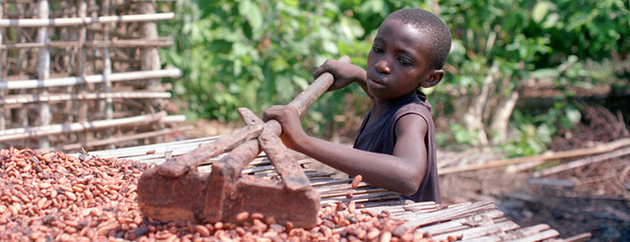
http://www.dw.de/filmmaker-romano-uncovers-chocolates-dark-secrets/a-15184900
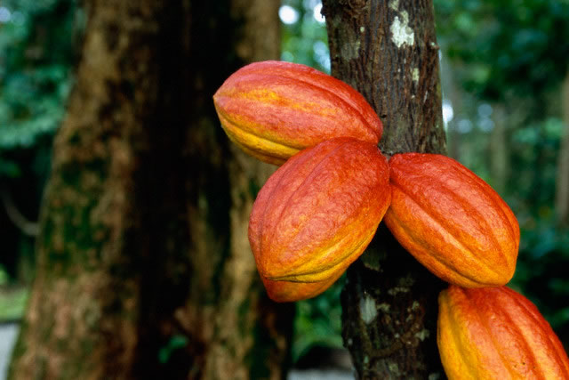
http://www.yapasmieux.info/civoire/Nationale/84.html
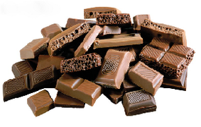
http://nobacks.com/chocolate-thirteen/

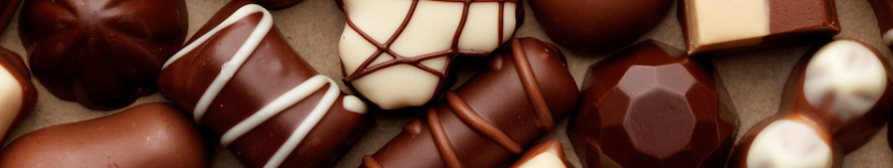
http://www.addcovers.com/category/all/page/345
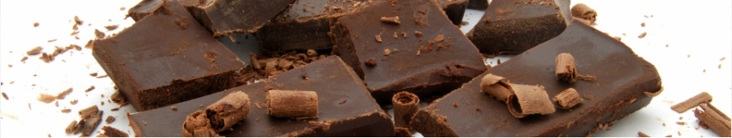
https://www.pinterest.com/iptameni/coffee-chocolate/
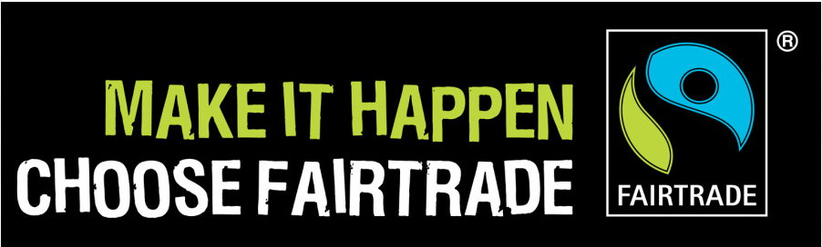
http://www.sandbachfairtrade.co.uk/
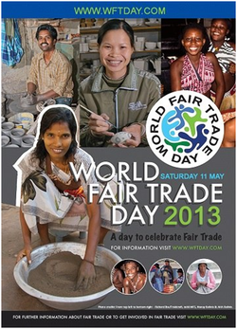
http://www.sandbachfairtrade.co.uk/
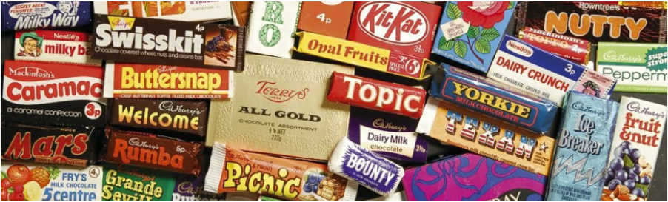
https://asenseofplaceblog.wordpress.com/2014/08/17/food-in-the-1970s-what-went-wrong/
http://www.mars.com/global/index.aspx
http://www.mondelezinternational.com/
http://www.nestle.com/media/medialibrary
http://www.bangkokpost.com/business/16218_info_cp-meiji-co-ltd-main-office.html
http://www.bangkokpost.com/business/16218_info_cp-meiji-co-ltd-main-office.html

http://www.ferrero.com/
http://en.academic.ru/dic.nsf/enwiki/292294
http://www.aubi-plus.com/duales-studium/august-storck-kg-bachelor-of-arts-betriebswirtschaftslehre-33790-halle-deutschland-41228.html
http://www.gamaconsumer.com/turkey-yildiz-holding-to-buy-united-biscuits/
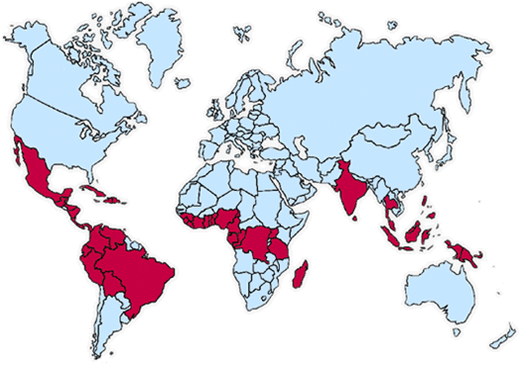
http://www.gamaconsumer.com/turkey-yildiz-holding-to-buy-united-biscuits/

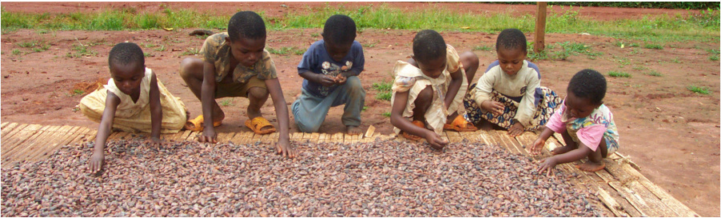
http://www.mintpressnews.com/child-slavery-in-chocolate-industry-leaves-a-bitter-taste-in-consumers-mouths/20259/
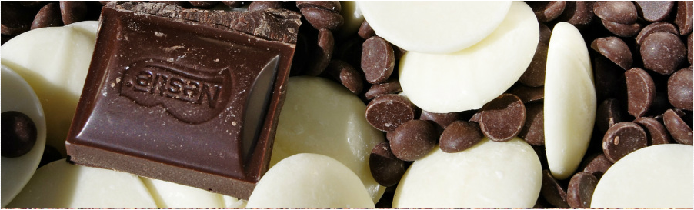
http://www.soyouwanna.com/chocolate-candy-making-techniques-7652.html
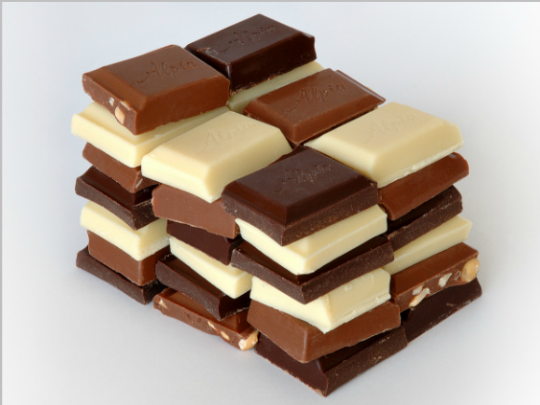
http://living.the-environmentalist.org/2008/02/where-to-buy-fair-trade-chocolate.html

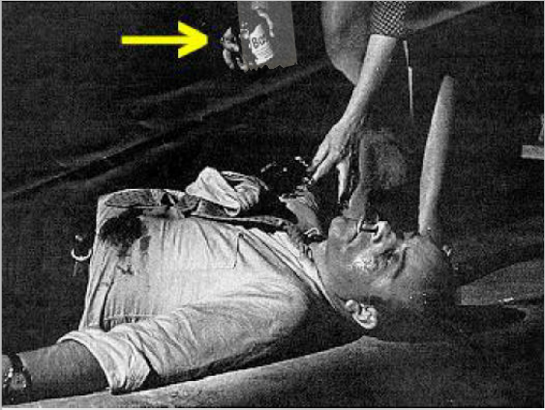
http://nostalgia.boscoworld.com/
http://www.happybirthdaywishesimages.com/exclusive-happy-birthday-wish-images-quotes-lover/happy-birthday-wish-love/
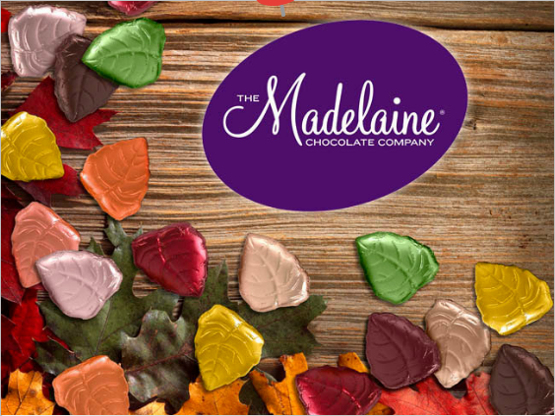
http://www.madelainechocolate.com/

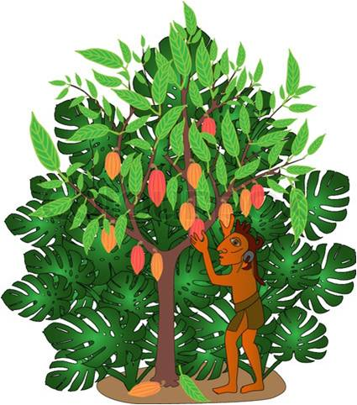
http://phototimes.ru/image/19431278/
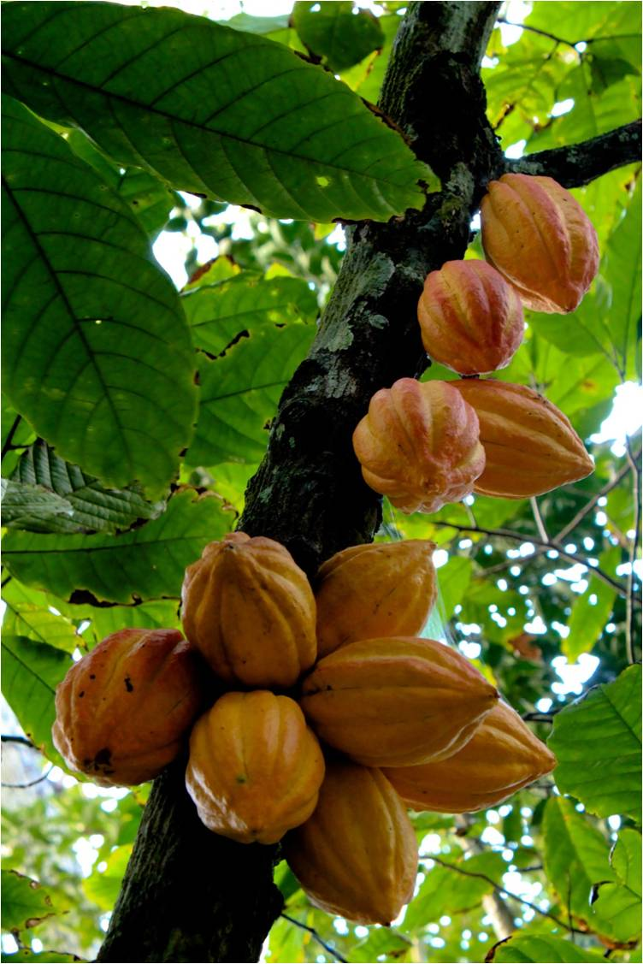
http://perfectresonance.com/crave-chocolate-read-this/

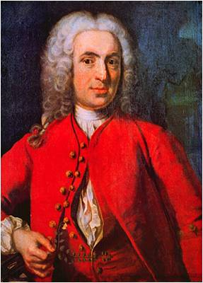
http://perfectresonance.com/crave-chocolate-read-this/
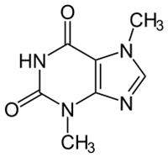
http://blogs.plos.org/speakeasyscience/2012/02/14/the-curious-toxic-chemistry-of-chocolate/
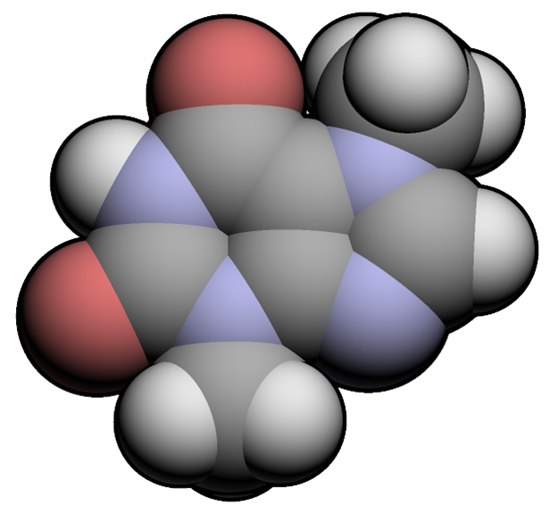
http://blogs.plos.org/speakeasyscience/2012/02/14/the-curious-toxic-chemistry-of-chocolate/

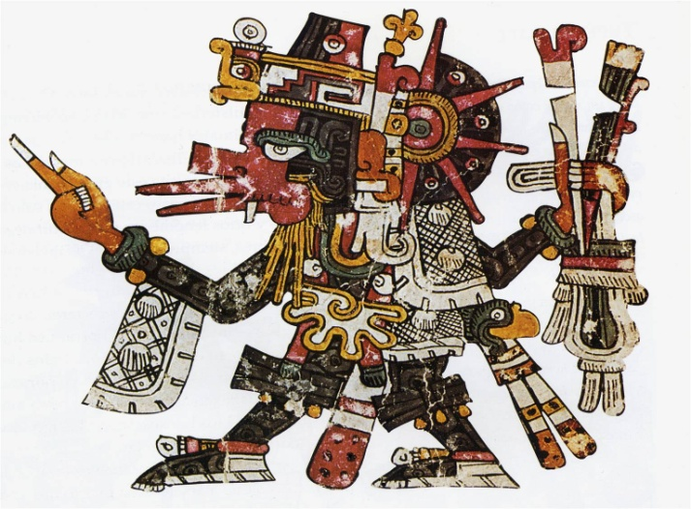
http://www.kingdavid8.com/_full_article.php?id=67f0dec9-6b9a-11e1-b1f8-842b2b162e97
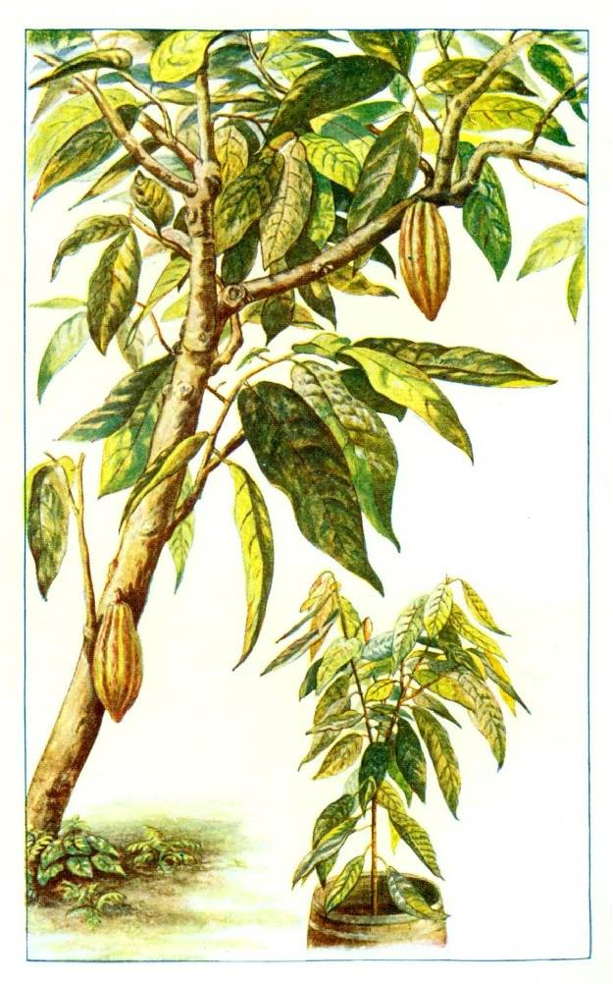
http://imgkid.com/cocoa-tree.shtml
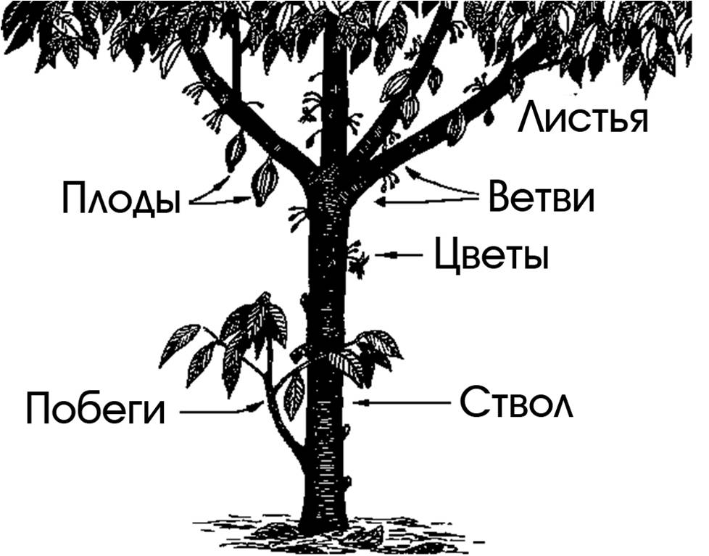
http://www.akitarescueoftulsa.com/fault-tree-diagram-and-gate/

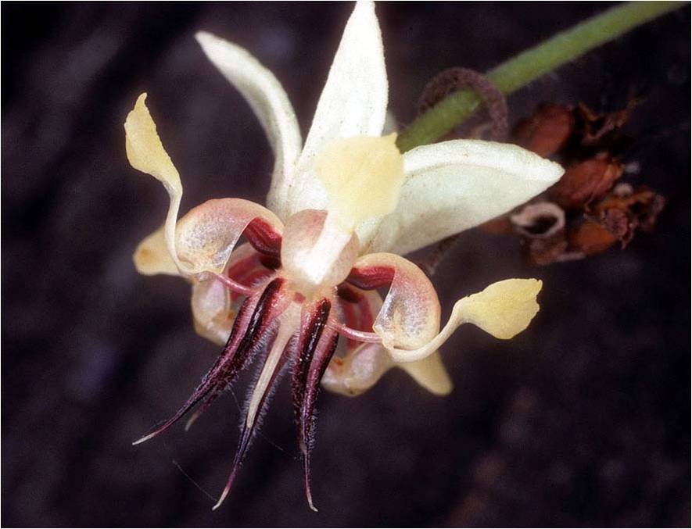
http://pixshark.com/cacao-tree-flower.htm
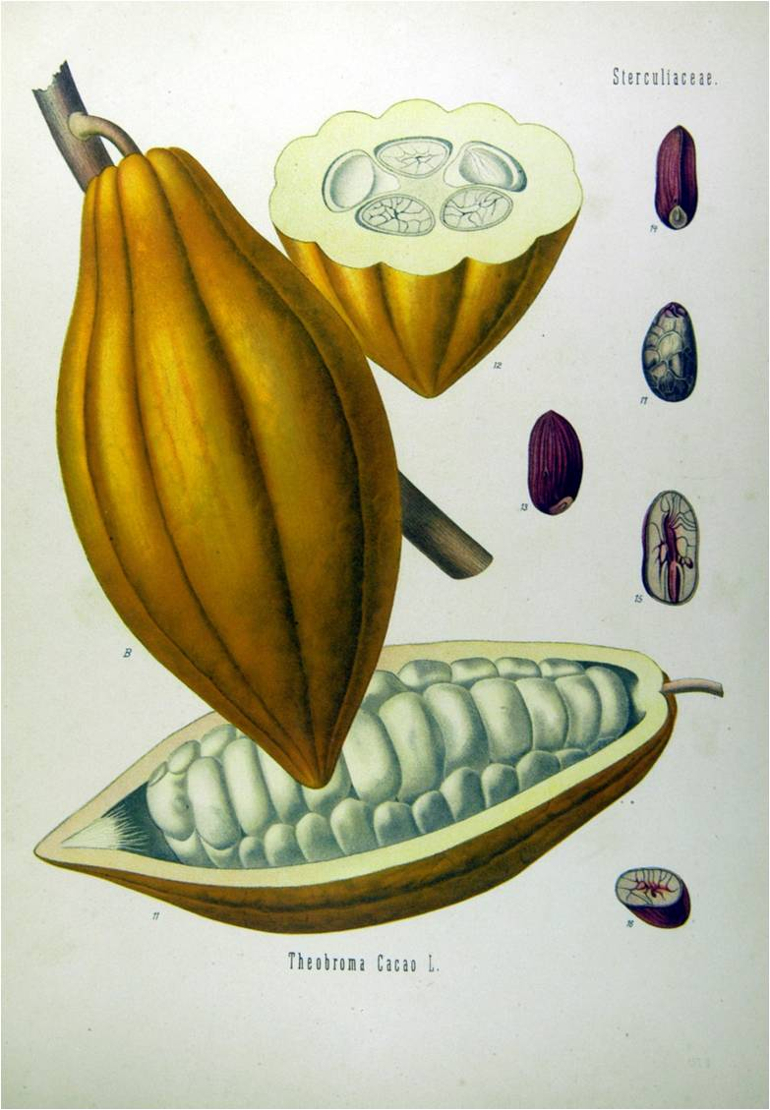
http://ideechocolat.blogspot.com/2014_09_01_archive.html
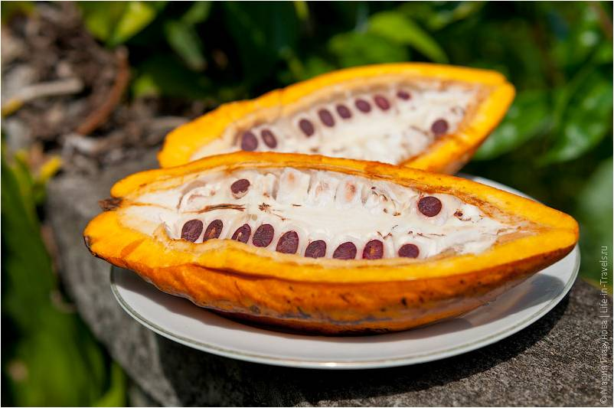
http://asiamir.com/indoneziya/proizvodstvo-organicheskogo-shokolada-na-bali.html

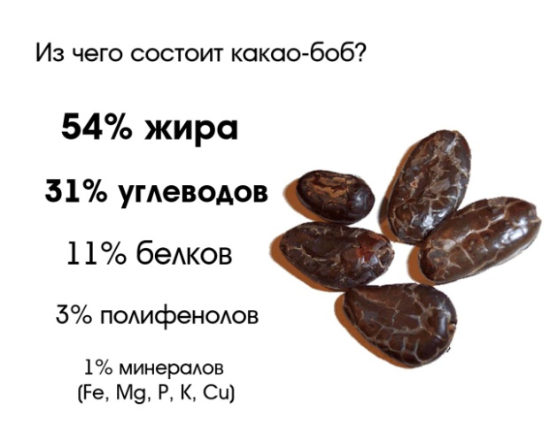
http://angelchocolates.com/menu/what-is-cacao/
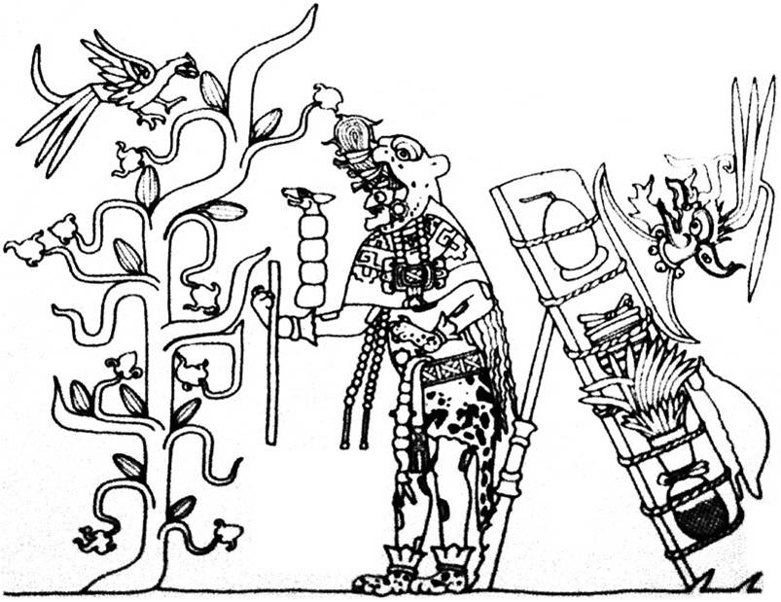
https://universmaya.wordpress.com/religion-sacrifices/
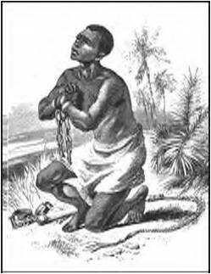
http://fineartamerica.com/featured/slavery-abolition-granger.html

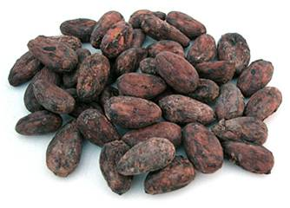
http://fineartamerica.com/featured/slavery-abolition-granger.html
http://fineartamerica.com/featured/slavery-abolition-granger.html
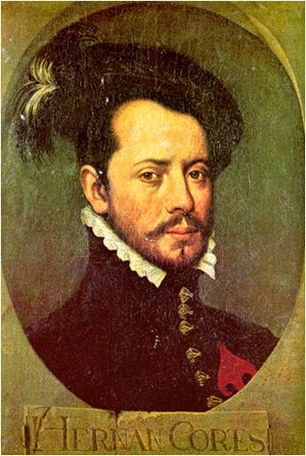
http://fineartamerica.com/featured/slavery-abolition-granger.html
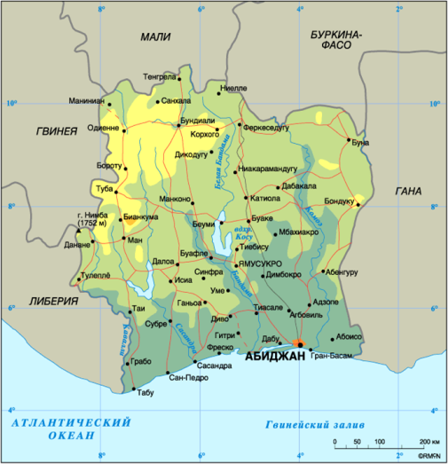
http://www.krugosvet.ru/node/35579
http://www.fao.org/ag/agp/AGPC/doc/Counprof/Ivorycoast/IvoryCoast.htm
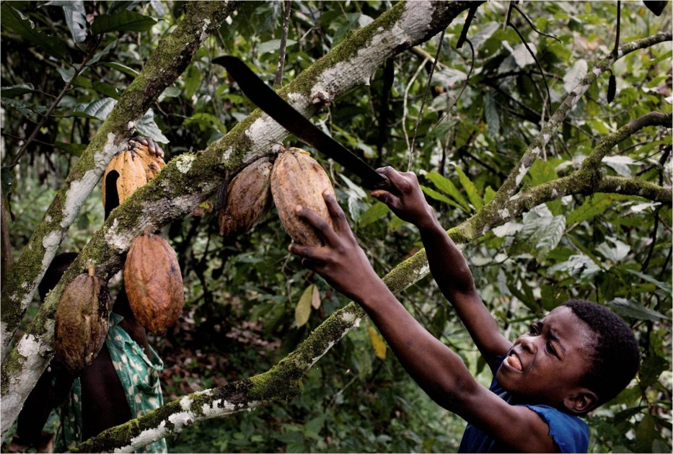
http://civileats.com/2011/06/07/kitchen-table-talks-report-chocolate-

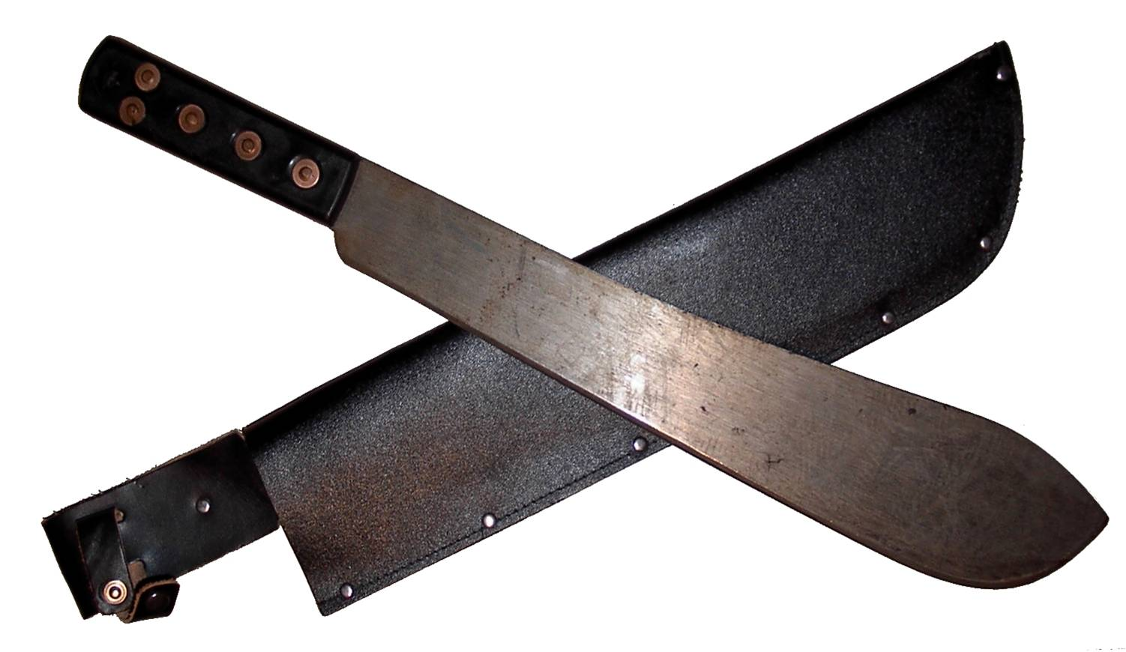
http://imgur.com/gallery/XXHWnww
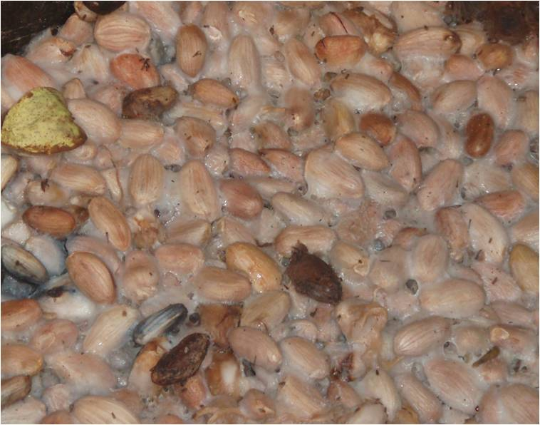
http://www.daintreeestates.com/processing_cocoa.htm
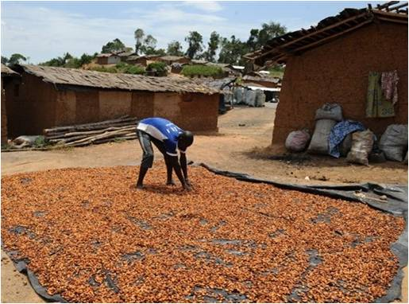
https://cocoanibs.wordpress.com/category/anique/

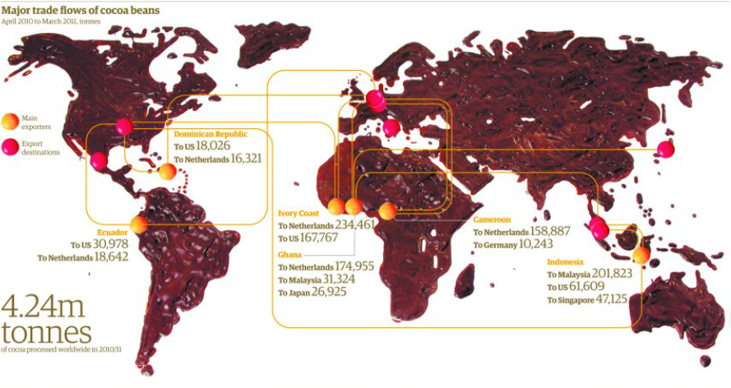
http://abagribusiness.weebly.com/cocoa--chocolate-making.html
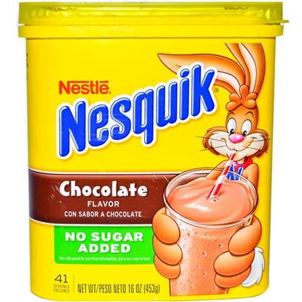
https://www.nesquik.com/adults/products/nesquikpowder/chocolate218oz.aspx
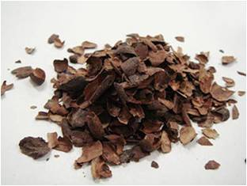
http://www.tpribor.ru/otchetpomol61.html

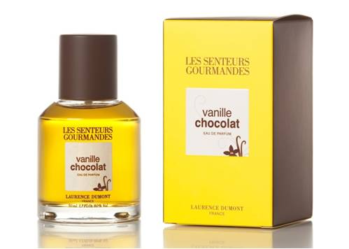
http://www.vanillabazaar.com/?c=perfume
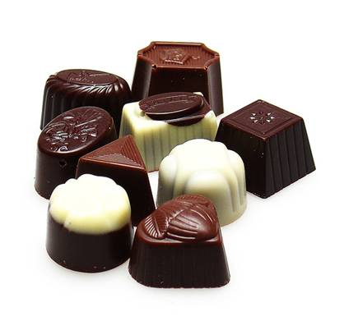
http://gourmetcandymaker.com/basics-of-candy-making/
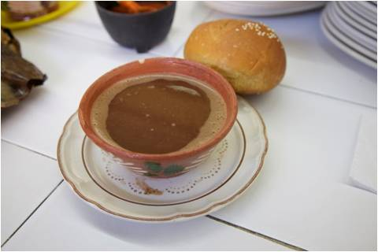
http://vremakin.livejournal.com/16085.html

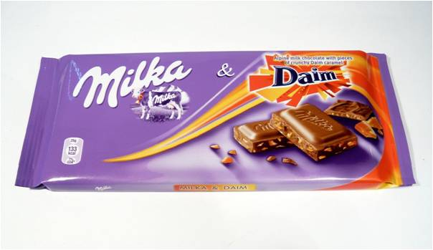
http://www.chocablog.com/reviews/milka-daim/
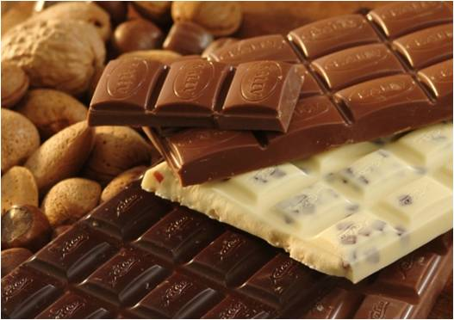
http://www.kalev.eu/en/the-world-of-sweets/what-is-chocolate
http://okoge.ru/story/shokoladnaya-maska-dlya-lica

http://www.balticadventure.com/en/countries/estonia/spa-in-estonia.html
http://www.vivichocolate.com/
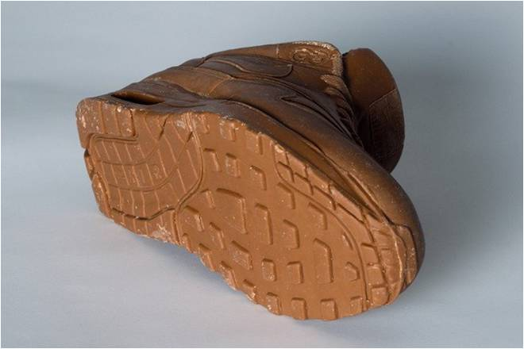
http://glipho.com/90chloe/chocolate-nike-trainer

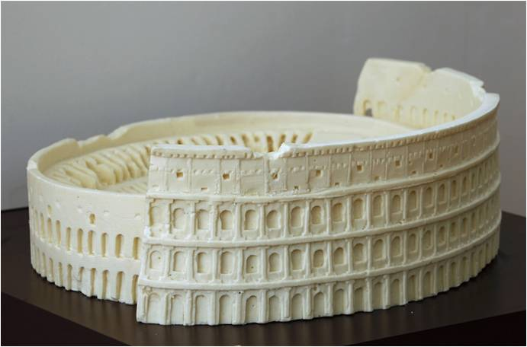
https://www.pinterest.com/cab83054/art-chocolate-sculpture/
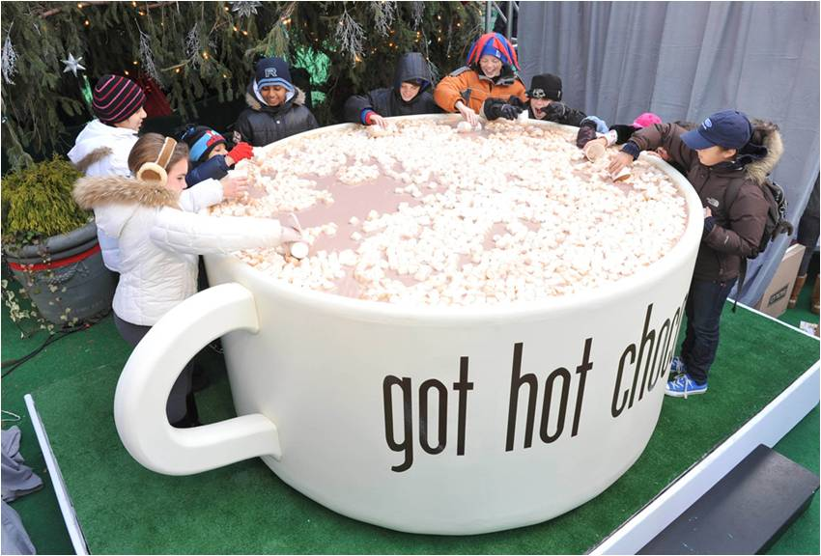
http://www.odditycentral.com/pics/worlds-largest-cup-of-hot-chocolate.html
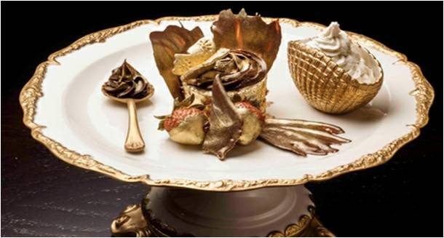
https://www.pinterest.com/bjsmit3/really/

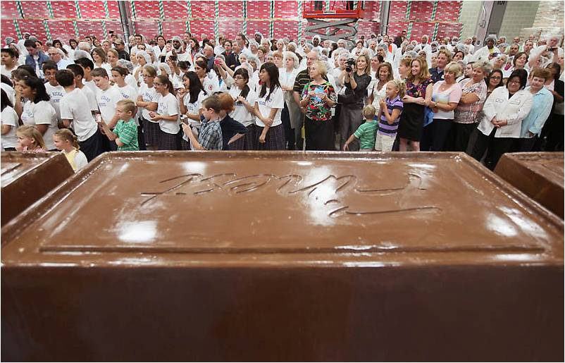
http://www.bitrebels.com/lifestyle/new-world-record-worlds-largest-chocolate-bar/
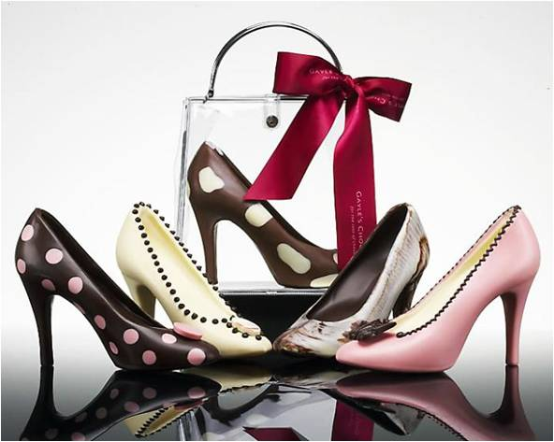
http://chocolate-sogood.blogspot.com/2008/04/chocolate-shoes-perfecti
http://neworleansgirl.buzznet.com/user/journal/7651211/salon-du-chocolat/

http://neworleansgirl.buzznet.com/user/journal/7651211/salon-du-chocolat/
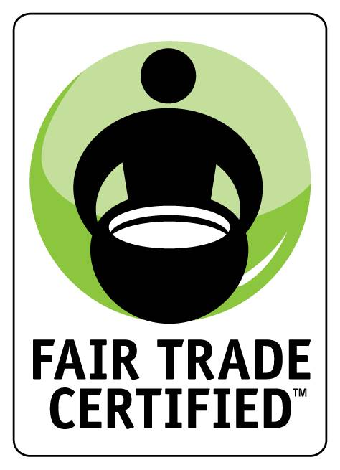
https://twitter.com/fairtradeusa
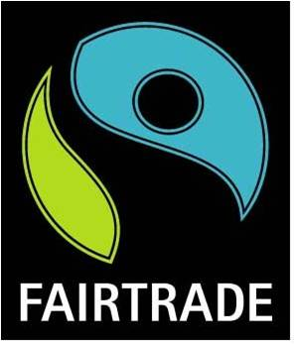
http://www.fairtrade.org.uk/products.htm
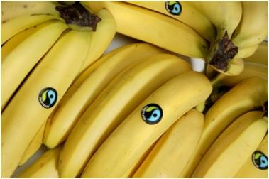
http://www.fairtrade.org.uk/en/media-centre/news/march-2014/response-to-announcement-fyffes-and-chiquita-are-to-merge
http://www.fanpop.com/clubs/chocolate/images/19468818/title/chocolate-rose-photo
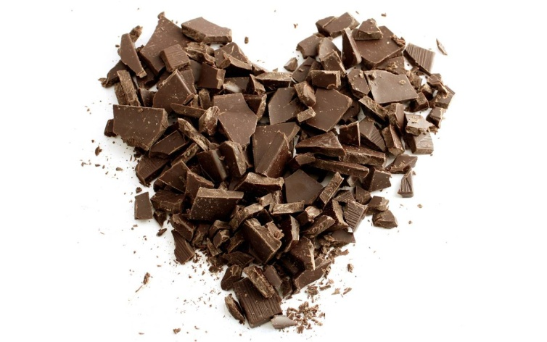
https://www.cacaoandcardamom.com/inspirations/

